21BDS0340

Abhinav Dinesh Srivatsa

Information Security and Audit Lab

Task – V

**Worksheet – I**

**Question 1**

Aim: Create 3 servers and 3 facilities in such a way that every facility can access 1 server, and the other 2 servers can only be accessed by one facility each.

Tools and Concepts Required:

* Cisco Packet Tracer
* Switch
* Router
* Servers
* Personal Computers
* Wiring

Layout:

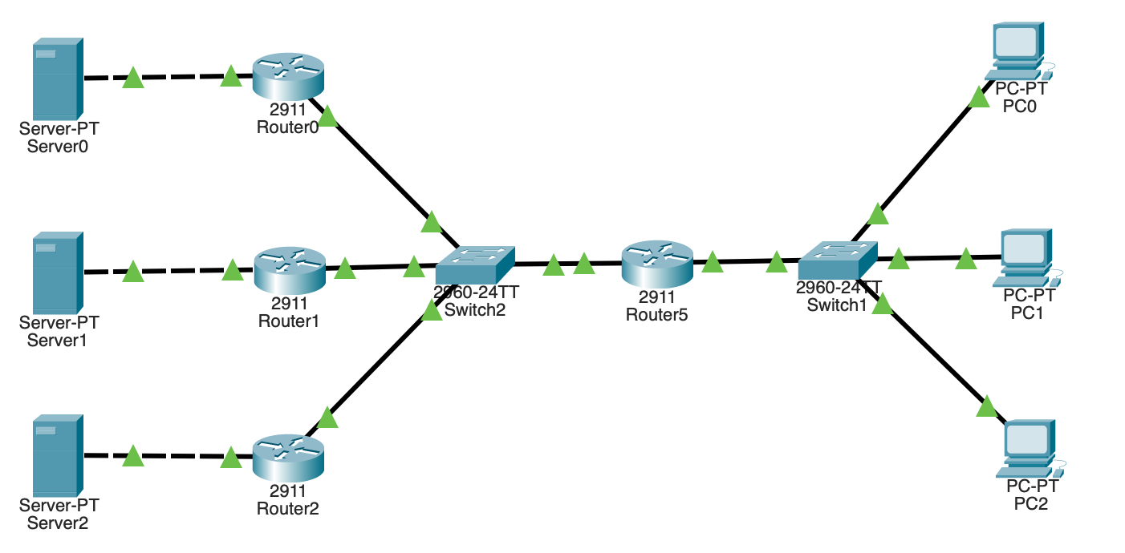

Security Analysis

The servers and client are very secure as they have no connections to the internet, and the only access to any computer is to be on the network directly (manually). This is a very safe environment for an office space and accomplishes the results with access groups.

**Question 2**

Aim: Deploy a network where a server is used to run an app used by 2 departments having: 3 administrative staff, and 4 technical staff

Tools and Concepts Required:

* Cisco Packet Tracer
* Switch
* Router
* Servers
* Personal Computers
* Wiring

Layout:

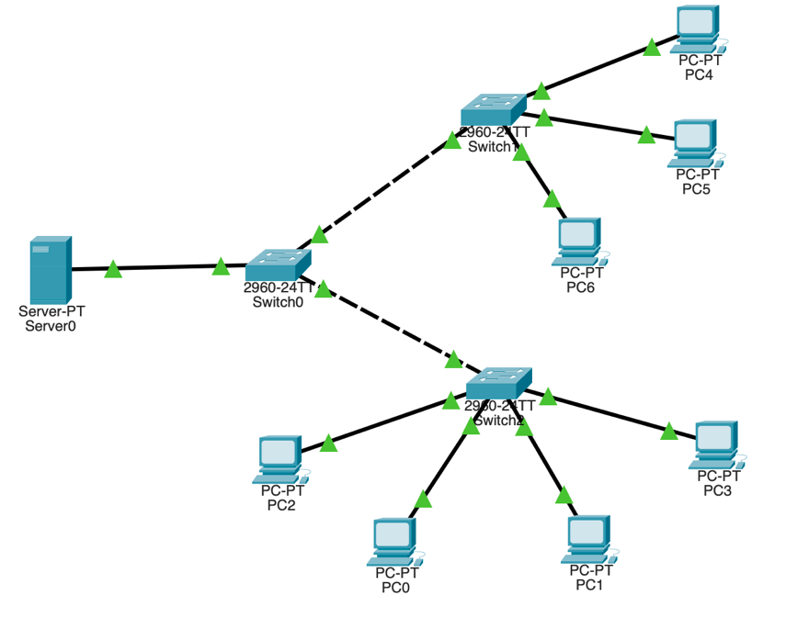

Website:

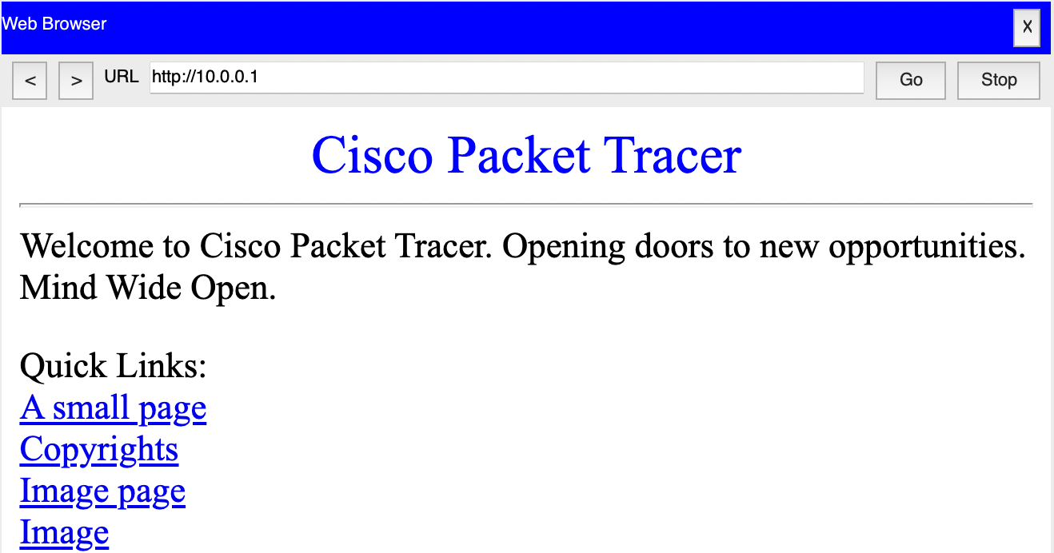

Security Analysis

The servers and client are very secure as they have no connections to the internet, and the only access to any computer is to be on the network directly (manually). This is a very safe environment for an office space.

**Worksheet – II**

**Question 3**

Aim: Create a network where there are 4 servers, 3 labs with 3 PCs per lab that can all access the servers

Tools and Concepts Required:

* Cisco Packet Tracer
* Switch
* Router
* Servers
* Personal Computers
* Wiring

Layout:

Security Analysis:

The servers and client are very secure as they have no connections to the internet, and the only access to any computer is to be on the network directly (manually). This is a very safe environment for a computer science lab to use.

**Question 4**

Aim: Demonstrate star topology and its variants. Use 5 end systems.

Tools and Concepts Required:

* Cisco Packet Tracer
* Switch
* Router
* Servers
* Personal Computers
* Wiring

Layout:

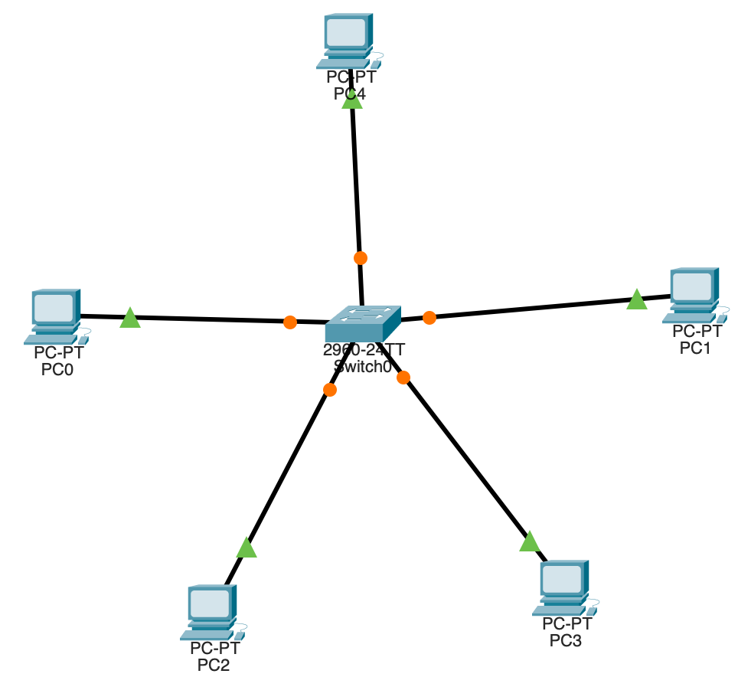

Security Analysis:

The servers and client are very secure as they have no connections to the internet, and the only access to any computer is to be on the network directly (manually). This is a very safe environment for any centrallised based system.